Paper Title Should be Concise and Informative and Should not Contain Abbreviations
First Author ª, Second Author ^{b}, and Third Author ^{c}
ª Department, College, University, City, Country, Email, ORCID
^{b} Department, College, University, City, Country, Email, ORCID
^{c} Department, College, University, City, Country, Email, ORCID
CORRESPONDENCE:
Corresponding Author Name
Email
Phone Number
ABSTRACT: Background: The abstract should be between 200 to 350 words and be “Structured Abstract” contains these five headings “In bold.” In the Background section, authors should briefly situate their study within the existing literature by highlighting the overarching challenge or gap that motivated the research. They should articulate why addressing this gap is important for the field and who will benefit from the findings. Aim for one clear, contextual paragraph rather than exhaustive detail. Objective: In the Objective section, authors should state the primary purpose of the study in a single, focused sentence. Use active phrasing such as “The aim of this study is to…,” specifying the population, intervention, and outcome of interest. Avoid vague expressions and ensure clarity about what the research seeks to achieve. Methods: In the Methods section, authors should briefly describe the study design, participant selection criteria, and data collection procedures. Include essential details such as sample size, setting, and measurement instruments. Outline the primary intervention or experiment and the analytical techniques used, for example, regression analysis, ANOVA, or thematic coding. Keep this description concise but sufficiently detailed to understand your approach. Results: In the Results section, authors should present the most important findings that directly address the study objective. Provide key quantitative metrics such as effect sizes, mean differences, confidence intervals, and p-values, or summarize major qualitative themes. Focus on reporting only the outcomes that support your conclusions, and avoid listing every result collected. Conclusions: In the Conclusions section, authors should interpret their findings by emphasizing their significance for theory, practice, or policy. Highlight two or three key messages that stem from your results and suggest practical applications or future research directions. Ensure that this final paragraph ties back to the Background and Objective sections to demonstrate a coherent narrative.
KEYWORDS: First keyword; Second keyword; Third keyword; Fourth keyword; Fifth keyword (Use four to seven keywords separated by a semicolon)
INTRODUCTION
Authors should open the Introduction with a compelling overview of the broad field, illustrating its real-world relevance or theoretical importance. In one or two concise sentences, explain the general topic area and why readers should care. This initial framing sets the stage and draws readers into the narrative.
Next, succinctly summarize key studies that have shaped current understanding of your topic. Highlight major findings, methodologies, and any debates or divergent results in the literature. Keep this review focused and selective-only include works directly related to your research question.
After surveying existing work, pinpoint the precise gap or unresolved issue your study addresses. Explain how prior research falls short-whether through limited scope, methodological constraints, conflicting evidence, or outdated data. This paragraph justifies the need for your investigation.
Build on the identified gap by outlining your study’s rationale: why your approach offers a fresh perspective or solution. Clearly state your primary aim, research questions, or hypotheses in active language. This linkage between gap and objective convinces readers of your study’s value.
Conclude the Introduction with a brief roadmap of the paper’s organization. Describe what each subsequent section covers-Methods, Results, Discussion, and Conclusions-to guide readers through your argument. This preview enhances clarity and helps readers navigate your manuscript.

materials and METHODS
Authors must use the font styles to help them use this template. All the style are depicted in Table 1.
Table 1. Font styles in this template (Do not put a period at the end of the Table’s caption)
Font style | Where to use
MJS_Title | In the title of the manuscript
Authors | In the authors’ names
Affiliations | In the affiliations of the authors
Abstract | In the abstract section
SECTIONS | In the titles of the main sections of the manuscript
Subsections | In the titles of the subsections of the manuscript
Subsubsections | In the titles of the subsubsections of the manuscript
Captions | In the caption of any environment of the manuscript (e.g. Algorithm, Figure, Scheme, Table, … etc)
References | In the references list
MJS_Normal | Elsewhere in the manuscript

Authors should clearly define the overall design while noting the multidisciplinary context. Whether employing experimental, observational, theoretical, computational, or mixed‐methods approaches, specify how your design aligns with your research questions. Describe whether the study is prospective or retrospective, laboratory or field‐based, and single‐ or multi‐center. Highlight any interdisciplinary frameworks or models that guide your methodology.
In this section, authors must detail the origins of their data or materials across disciplines. For empirical studies, describe participant populations, inclusion/exclusion criteria, and sampling methods. For computational or modeling work, specify datasets, software environments, or simulation parameters. For archival or textual research, note the corpus, archives, or databases used and any selection criteria applied.
Authors should list all tools, instruments, and technologies employed, ensuring clarity for readers from diverse fields. This may include laboratory assays, survey questionnaires, sensors, computational algorithms, software packages (with version numbers), or textual coding frameworks. For adapted or novel instruments, briefly explain development, validation, and reliability assessments.
Authors should provide a step‐by‐step account of how methods were executed, accommodating varied disciplinary practices. Describe experimental protocols, fieldwork logistics, data collection schedules, participant training, or coding workflows. If using blinding, randomization, or standardization across sites, clarify the mechanisms and steps taken to maintain consistency.
Authors should outline analytic techniques suitable to their discipline and accessible to a broad readership. For quantitative work, specify software (including version), statistical tests or modeling algorithms, handling of missing data, and significance thresholds. For qualitative research, describe coding processes, thematic analysis, or discourse analysis methods, including triangulation or validity checks. In computational studies, note simulation validation, sensitivity analyses, and reproducibility measures
Use of Subsections and Subsubsections
Authors should organize the manuscript’s main body with a clear hierarchy of headings to guide readers through complex, multidisciplinary content. Use numbered subsections (e.g., 2. Methods, 2.1 Participants) to group major topics or phases of your study, and employ subsubsections (e.g., 2.1.1 Inclusion Criteria) only when further breakdown clarifies distinct concepts or procedures. Limit your structure to three heading levels-section, subsection, subsubsection-to avoid over fragmentation. Ensure each heading is concise, parallel in style, and descriptive enough to stand alone: readers scanning your paper should immediately grasp the content of each block. Maintain consistent formatting (numbering scheme, font size, capitalization) throughout. Reserve subsubsections for substantive subdivisions; if a subsubsection becomes too brief or trivial, merge it into its parent subsection to preserve narrative flow. This disciplined approach enhances readability and helps a diverse audience navigate your work’s interdisciplinary arguments.

RESULTS AND DISCUSSION
Authors should present your findings in a logical sequence that mirrors the objectives, beginning with primary outcomes followed by secondary or exploratory analyses. Report quantitative data with appropriate metrics-means, variability measures, effect sizes, confidence intervals, and p-values-or summarize qualitative themes with illustrative quotes, ensuring neither interpretation nor speculation appears here. Use tables and figures to distill complex data, fully describing each in the text. For a multidisciplinary audience, define any field-specific terms or metrics and highlight cross-disciplinary comparisons where relevant. Note unexpected or null findings without drawing conclusions, reserving discussion of implications for the next paragraph.
Authors should interpret and contextualize the results by comparing them with existing literature across all pertinent disciplines, explaining how your findings confirm, refine, or challenge prior work. Begin with a concise restatement of the most important results, then explore their theoretical, methodological, and practical significance for each field involved. Address limitations transparently-considering design, sample, and analytical constraints-and discuss their potential impact on the findings. Propose clear implications for practice, policy, or future research, suggesting specific follow-up studies or applications. Conclude with a unifying statement that emphasizes your study’s novel contribution to the broader scientific community.
General Presentation
The presentation of your written work is important: first impressions do count, and poorly presented work might lead your tutor to think that the work has been rushed or that you do not really care about it.
Particular faculties or courses may have their own guidelines for different aspects of presentation, so always check your own course documentation or with course tutors. What follows is general advice on the presentation of courses assignments which is usually, but not always, appropriate.
Figures in a scientific manuscript play a crucial role in visually presenting data, illustrating concepts, and enhancing understanding. When referring to figures in the manuscript, it's essential to provide clear and concise descriptions to guide the reader through the content. Here's how you can handle figures in your manuscript:
- Figure Placement
Figures should be strategically placed within the text to complement and support the narrative. Typically, figures are inserted after they are first mentioned in the text or grouped together at the end of relevant sections or at the end of the manuscript.
- Figure Numbering
Each figure should be assigned a unique number (e.g., Figure 1, Figure 2, etc.) and accompanied by a descriptive caption. Figure numbers should appear sequentially throughout the manuscript.
- Descriptive Captions
Captions should be concise but informative, providing a brief title or description of the figure's content. Captions can also include additional details such as legends, labels, or explanations of symbols used in the figure, do not use period at the end of the caption.
- In-Text References
When referring to a figure within the text, use the figure number (e.g., ``Figure 1'') to direct the reader to the corresponding visual representation. For example, ``As shown in Figure 1, the relationship between variables X and Y is evident.''
- Consistency and Clarity
Ensure consistency in formatting and labeling of figures throughout the manuscript. Figures should be clear, legible, and appropriately sized to fit within the document.
- Permissions and Citations
If the figures are adapted or reproduced from previously published sources, provide proper citations and obtain necessary permissions as per copyright guidelines.
- Accessibility
Consider accessibility when creating figures, ensuring that they are comprehensible to readers with visual impairments. Provide alternative text descriptions for figures when necessary.
Figure captions should be below the figures. Insert figures and tables after they are cited in the text. Use the "Figure 1", even at the beginning of a sentence. Authors can use Figure 1 as an example for their figures. When placing more than two figures and photos under the same number of title, assign subtitles by dividing each figure and photo by (a) or (b), as illustrated in Figure 2. Do not use a shadow or frame around the figure. Multi-curve graphs should have individual curves marked with a symbol; the meaning of the symbol should be explained in the figure caption. Good quality should be supplied for the illustrations.

Figure 1. The logo of the Al-Mustansiriyah Journal of Science

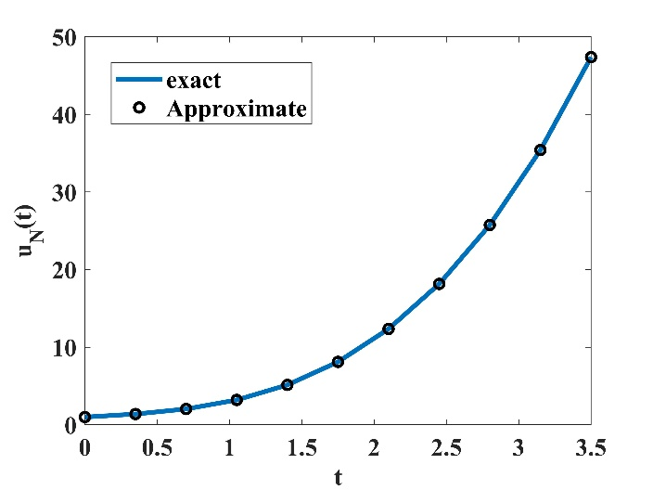 | 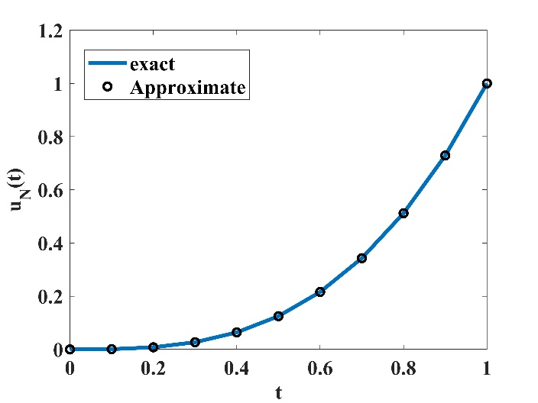
(a) | (b)
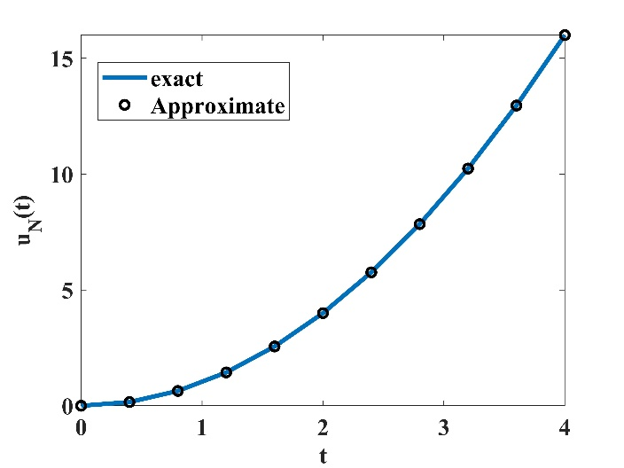 | 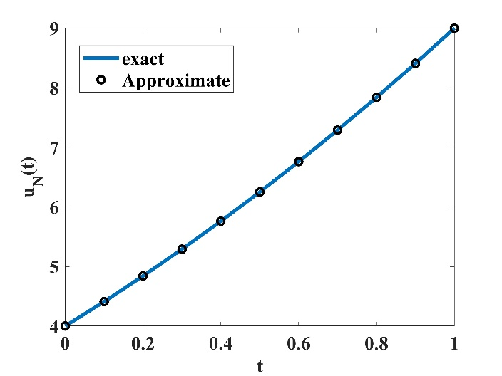
(c) | (d)
Figure 2. Comparison between the exact and numerical solutions for (a) Example 1; (b) Example 2; (c) Example 3; (d) Example 4 [1]

Tables
Insert tables after they are cited in the text. Tables are referred to in the text by “Table n” (capital T). Table heads should appear above the tables. When placing more than two tables under the same number of title, assign subtitles by dividing each table by (a) or (b). For example: Table 1, Table 2(a) and 2(b). Avoid any colors or shadings in the table.
Units
Use either SI (MKS) or CGS as primary units. (SI units are encouraged.) English units may be used as secondary units (in parentheses). An exception would be the use of English units as identifiers in trade, such as “3.5-inch disk drive.” Avoid combining SI and CGS units, such as current in amperes and magnetic field in oersteds. This often leads to confusion because equations do not balance dimensionally. If you must use mixed units, clearly state the units for each quantity that you use in an equation.
Some Common Mistakes
The word “data” is plural, not singular. In American English, periods and commas are within quotation marks, like “this period.” A parenthetical statement at the end of a sentence is punctuated outside of the closing parenthesis (like this). (A parenthetical sentence is punctuated within the parentheses.) A graph within a graph is an “inset,” not an “insert.” The word alternatively is preferred to the word “alternately” (unless you mean something that alternates). Do not use the word “essentially” to mean “approximately” or “effectively.” Be aware of the different meanings of the homophones “affect” and “effect,” “complement” and “compliment,” “discreet” and “discrete,” “principal” and “principle.” Do not confuse “imply” and “infer.” The prefix “non” is not a word; it should be joined to the word it modifies, usually without a hyphen. There is no period after the “et” in the Latin abbreviation “et al.” The abbreviation “i.e.” means “that is,” and the abbreviation “e.g.” means “for example.” An excellent style manual for science writers is [7].
Equations
Equations and formulae should be typed in MathType or MS Word equation editor, and numbered consecutively with Arabic numerals in parentheses on the right hand side of the page (if referred to explicitly in the text). They should also be separated from the surrounding text by one space, as illustrated by (1)-(4) [1, 2].

Conclusion
In the Conclusions section, authors should begin by briefly restating the study’s primary aim and summarizing the key findings in light of that objective, emphasizing how these results advance understanding across the journal’s multiple disciplines. They should then draw out the broader implications for theory, practice, or policy, highlighting any cross-field applications or innovations that emerged. Next, authors may reiterate the most critical limitation(s) that readers should bear in mind and suggest concrete avenues for future research-whether through expanded sample sizes, alternative methodologies, or deeper interdisciplinary collaboration. Finally, they should close with a concise, forward-looking statement that captures the novel contribution of the work and its potential to inspire continued inquiry or real-world impact.
Supplementary Materials
This section is dedicated to providing additional information that is not included in the main text but may be useful or necessary for a deeper understanding of the study. The elements that can be included in the "Supplementary Material" section are:
Complete Data Sets: Provide large data sets or detailed tables that may be too lengthy or complex to include in the main text.
Detailed Graphs: Provide detailed graphs or illustrations that explain technical or methodological aspects not fully covered in the main text.
Detailed Procedures: Provide additional experimental steps or a more detailed explanation of the methods used.
Used Code or Software Tools: Share the code or scripts used for data analysis.
Video or Audio Files: Provide links to video or audio files that demonstrate parts of the experiment or methods used.
Mathematical or Statistical Analyses: Provide additional details on mathematical or statistical analyses that were performed but not fully included in the main text.
Author Contributions
The author contributions are used to provide transparency regarding individual contributions to papers. Authors must provide an author contribution, specifying their individual contributions using the following 14 possible roles:
Conceptualization; Data curation; Formal analysis; Funding acquisition; Investigation; Methodology; Project administration; Resources; Software; Supervision; Validation; Visualization; Writing – original draft; Writing – review & editing.
The corresponding author is responsible for ensuring the accuracy of the author contributions and obtaining agreement from all authors. For each author, provide their name followed by their specific contributions. Use commas to separate roles. For example:
Sample author contributions
Jan Doe: Conceptualization, Methodology, Investigation, and Writing - original draft. Zhang San: Formal analysis, Visualization, and Writing - review & editing. Ajay Kumar: Investigation, Software, Funding acquisition and Supervision.
Manuscripts may not involve all author contributions roles, and authors can contribute through multiple roles.
Authors are encouraged to refer to the CRediT website for detailed descriptions of each role.
Funding
Please add: "None" or "This research received no external funding" or "This research was funded by NAME OF FUNDER grant number XXX." and "The APC was funded by XXX". Check carefully that the details given are accurate and use the standard spelling of funding agency names at \url{https://search.crossref.org/funding}, any errors may affect your future funding.
Data availability statements
“All data generated or analyzed during this study are included in this published article (and its supplementary material file).” Or We encourage all authors of articles published in MJS journal to share their research data. In this section, please provide details regarding where data supporting reported results can be found, including links to publicly archived datasets analyzed or generated during the study. Where no new data were created, or where data is unavailable due to privacy or ethical restrictions, a statement is still required.
Acknowledgments
This section is used to express gratitude to individuals or organizations that provided support or assistance with the research. Funding Sources: Thank the institutions or organizations that provided financial support for the research. Technical Assistance: Thank those who provided technical support or help with data collection and analysis. Institutional Support: Thank institutions that assisted with the research, such as universities or research centers. An example of how to write an "Acknowledgments" section might be:
"We would like to thank [Name] for their invaluable assistance with [specific contribution, e.g., data analysis, technical support]. We also appreciate the support of [Institution or Laboratory Name] for providing the necessary facilities and resources."
Conflicts of interest
Declare conflicts of interest or state ``The authors declare no conflicts of interest.'' Authors must identify and declare any personal circumstances or interest that may be perceived as inappropriately influencing the representation or interpretation of reported research results. Any role of the funders in the design of the study; in the collection, analyses or interpretation of data; in the writing of the manuscript; or in the decision to publish the results must be declared in this section. If there is no role, please state ``The funders had no role in the design of the study; in the collection, analyses, or interpretation of data; in the writing of the manuscript; or in the decision to publish the results.''

Ethical Approval (optional)
This section is used to disclose the ethical approvals obtained from relevant committees or bodies to ensure that the study was conducted in accordance with ethical standards. Responsible body: identify the name of the ethics committee or board that granted the ethical approval, such as the institutional review board (irb) or ethics committee. Approval number: include the approval number or reference if available, as it helps in verifying the approval. Participant consent: if the study involves human subjects, confirm that informed consent was obtained from all participants. An example of how to write the "ethical approval" section might be:
"The study was approved by the [name of ethics committee] under approval number [approval number]."
Declaration of Generative AI Use
This statement should appear at the end of the manuscript, before the references, and must include: The AI tool(s) used (e.g., ChatGPT). The specific purpose of use (e.g., language polishing). A statement confirming that the authors reviewed, verified, and edited all outputs. Example acceptable statement: “During the preparation of this manuscript, the author(s) used [NAME TOOL / SERVICE] [Ex: ChatGPT (OpenAI, model GPT-5.1)] for [REASON] [Ex: language editing and text improvement]. After using this tool, the author(s) thoroughly reviewed and revised the generated content, taking full responsibility for the accuracy and integrity of the final manuscript.” If no AI tools were used, authors must state: “The author(s) declare that no generative AI or AI-assisted technologies were used in the preparation of this manuscript.”
References
Authors submitting to Al-Mustansiriyah Journal of Science must format references in IEEE style, which requires citations to be numbered consecutively in square brackets within the text (e.g., [3] or [4, 5]) in the order of their appearance; these correspond to a sequentially numbered reference list at the end of the manuscript where references should be cited by their number only, except at the beginning of a sentence (e.g., "Reference [3] shows..."). The reference list must include all authors' names without using "et al.," and each entry should be formatted with the paper title in quotation marks (capitalizing only the first word and proper nouns) and the journal or book title in italics. For journal articles, the journal name must be provided in full, followed by the volume, issue, page numbers (or article number, if applicable), and year; it is preferred to include the abbreviated month if an issue number is absent and to always provide the full DOI link when available. Additional notes include citing papers accepted for publication as "in press," and for translation journals, providing the English citation followed by the original language citation.
[1] A. T. Abed and E. S. Al-Rawi, "A New Spectral Mittag-Leffler Weighted Method to Solve Variable Order Fractional Differential Equations," Al-Mustansiriyah Journal of Science, vol. 35, no. 4, pp. 80–91, 12/30 2024, doi: 10.23851/mjs.v35i4.1564.
[2] S. A. Somma, R. O. Omotinuwe, and N. O. Abdurrahman, "Mathematical Model for the Control of Unemployment in Nigeria Incorporating Vocational Education and Apprenticeship," Al-Mustansiriyah Journal of Science, vol. 36, no. 2, pp. 1–17, 06/30 2025, doi: 10.23851/mjs.v36i2.1655.
[3] R. S. Mohammed and R. S. Ahmed, "Estimation of radiological hazards to lungs and some organs due to soil gas radon, thoron, and their progeny using CR-39 polymer detector in Kadhimya, Baghdad, Iraq," European Physical Journal Plus, vol. 140, no. 2, 2025, Art no. 93, doi: 10.1140/epjp/s13360-025-06045-1.
[4] M. O. Al-Amr and S. El-Ganaini, "New exact traveling wave solutions of the (4+1)-dimensional Fokas equation," Computers and Mathematics with Applications, vol. 74, no. 6, pp. 1274–1287, 2017, doi: 10.1016/j.camwa.2017.06.020.
[5] Y. Baqi and A. H. Ismail, "Microwave-Assisted Synthesis of Near-Infrared Chalcone Dyes: a Systematic Approach," ACS Omega, vol. 10, no. 7, pp. 7317–7326, 2025, doi: 10.1021/acsomega.4c11066.
[6] M. O. Al-Amr, H. Rezazadeh, K. K. Ali, and A. Korkmazki, "N1-soliton solution for Schrödinger equation with competing weakly nonlocal and parabolic law nonlinearities," Communications in Theoretical Physics, vol. 72, no. 6, 2020, Art no. 065503, doi: 10.1088/1572-9494/ab8a12.
[7] A. H. Farhan and M. Y. Kamil, "Texture Analysis of Breast Cancer via LBP, HOG, and GLCM techniques," in IOP Conference Series: Materials Science and Engineering, 2020, vol. 928, 7 ed., doi: 10.1088/1757-899X/928/7/072098.
[8] R. S. Mohammed, K. A. Aadim, and K. A. Ahmed, "Estimation of in vivo toxicity of MgO/ZnO core/shell nanoparticles synthesized by eco-friendly non-thermal plasma technology," Applied Nanoscience (Switzerland), vol. 12, no. 12, pp. 3783–3795, 2022, doi: 10.1007/s13204-022-02608-1.
[9] I. M. S. Al-Kadmy, S. A. Abid, S. N. Aziz, Z. Al-Kadmy, A. Suhail, S. S. Al-Jubori, E. N. Naji, E. alhomaidi, R. Yahia, A. M. Algammal, G. E. S. Batiha, and H. F. Hetta, "The secrets of environmental Pseudomonas aeruginosa in slaughterhouses: Antibiogram profile, virulence, and antibiotic resistance genes," Folia Microbiologica, vol. 69, no. 4, pp. 805–822, 2024, doi: 10.1007/s12223-023-01116-1.
[10] R. S. Mohammed, A. Sudhakaran, M. Y. A. Mostafa, and G. Abbady, "Synthesize of ZnO and CuO nanoparticles with plasma jet at different treatment times and testing its optical parameters with UV-Vis-NIR," Applied Physics A: Materials Science and Processing, vol. 130, no. 8, 2024, Art no. 533, doi: 10.1007/s00339-024-07651-z.
[11] G. L. Mohsen, A. M. Abdula, A. M. Jassim, W. F. Rodhan, and N. B. Ayrim, "New 3,5-disubstituted-4,5-dihydroisoxazole derivatives: Synthesis, antimicrobial, antioxidant and docking study against glucosamine-6-phosphate synthase," presented at the Journal of Physics: Conference Series, 2021, 012042.
[12] Y. Baqi, "Anthraquinone Dyes: A Synthetic and Chemical Characterization Protocol for an Industrial Chemistry Laboratory Course," Journal of Chemical Education, vol. 99, no. 3, pp. 1441–1447, 2022, doi: 10.1021/acs.jchemed.1c00865.
[13] M. R. Baker and U. Solanki, "Artificial Intelligence Models in Pattern Recognition," in Handbook of Artificial Intelligence Applications for Industrial Sustainability: Concepts and Practical Examples: CRC Press, 2024, pp. 18–36.
[14] R. S. Mohammed and M. F. Al -Marjani, "DBD plasma as a practical approach to sterilization of dental instruments," Physica Scripta, vol. 99, no. 4, 2024, Art no. 045601, doi: 10.1088/1402-4896/ad2e5a.
[15] K. F. Al-azawi, B. A. Hasoon, R. A. Ismail, K. H. Rasool, M. S. Jabir, S. S. Shaker, K. H. Jawad, A. M. Abdula, S. Ghotekar, and A. A. Swelum, "Pharmaceutical properties of novel 3-((diisopropylamino)methyl)-5-(4-((4-(dimethylamino) benzylidene) imino) phenyl)-1,3,4-oxadiazole-2(3 H)-thione," Scientific Reports, vol. 15, no. 1, 2025, Art no. 15019, doi: 10.1038/s41598-025-98061-5.
[16] Y. K. Al-Hilaly, J. E. Rickard, M. Simpson, J. M. D. Storey, C. R. Harrington, C. M. Wischik, and L. C. Serpell, "A key region of Tau that is able to drive assembly and modulate inhibition by Hydromethylthionine," Journal of Molecular Biology, vol. 437, no. 17, 2025, Art no. 169231, doi: 10.1016/j.jmb.2025.169231.
[17] I. M. S. Al-Kadmy, N. A. Al-Saryi, I. M. A. Salman, E. T. Garallah, S. N. Aziz, S. S. Al-Jubori, E. N. Naji, E. Alhomaidi, S. S. Alsharari, Y. N. Ramadan, and H. F. Hetta, "Multidrug-resistant Serratia marcescens: A growing threat in Iraqi intensive care units," Gene Reports, vol. 39, 2025, Art no. 102197, doi: 10.1016/j.genrep.2025.102197.

