Al-Mustansiriyah Journal of Science
ISSN: 1814-635X (print) 2521-3520 (electronic)

Paper Title should be Limited to 25 Words and should not Contain Abbreviations
First Author ª, Second Author ^{b}, and Third Author ^{c}
aDepartment,College, University, City, Country, Email, ORCID
bDepartment, College, University, City, Country, Email, ORCID
cDepartment, College, University, City, Country, Email, ORCID
CORRESPONDANCE:
Corresponding Author Name
Email

ABSTRACT: A single paragraph of between 200 and 350 words as a maximum. For research articles, abstracts should give a pertinent overview of the work. We strongly encourage authors to use the following style of structured abstracts, but without headings: Objective: place the question addressed in a broad context and highlight the purpose of the study; Methods: Describe the study design, participants, materials, procedures, and data analysis methods used; Results: Summarize the main findings of the study, including key quantitative or qualitative results; Conclusions: : Discuss the implications of the findings and any recommendations for future research or practice. The abstract should be an objective representation of the article, it must not contain results which are not presented and substantiated in the main text and should not exaggerate the main conclusions.
KEYWORDS: Keyword1; Keyword2; Keyword3; Keyword4; Keyword5

INTRODUCTION
Start with a general statement about the broad topic area of the study, providing context for the research.
Provide background information on the topic, including relevant literature reviews and previous research findings.
Highlight the significance or importance of the research topic, indicating why it is relevant to the field and why it warrants further investigation.
Identify gaps or limitations in the existing literature that the current study aims to address. State the specific objective or research question that the study seeks to answer.
Please include the contributions of this manuscript in this section. The contributions should clearly state the problem you’re addressing, your unique approach, and the significance of your work.
Optionally, briefly outline the structure of the paper, indicating how the subsequent sections will address the research objective.

METHODS
The Materials and Methods section is a vital component of any formal lab report. This section of the report gives a detailed account of the procedure that was followed in completing the experiment(s) discussed in the report. Such an account is very important, not only so that the reader has a clear understanding of the experiment, but a well written Materials and Methods section also serves as a set of instructions for anyone desiring to replicate the study in the future.
There are several common mistakes that are often found in the Materials and Methods section of a lab report. One major concern is deciding upon the correct level of detail [1]. It is often very easy for a writer to get carried away and include every bit of information about the procedure, including extraneous information like the number of times he(or she) washed their hands during the experiment. A good guideline is to include only what is necessary for one recreating the experiment to know. Keeping this in mind will lead to a Materials and Methods section that is thoroughly written, but without the kind of unnecessary detail that breaks the flow of the writing. Another common mistake is listing all of the materials needed for the experiment at the beginning of the section [1].

RESULTS AND DISCUSSION
The results section is where you tell the reader the basic descriptive information about the scales you used (report the mean and standard deviation for each scale). If you have more than 3 or 4 variables in your paper, you might want to put this descriptive information in a table to keep the text from being too choppy and bogged down (see the APA manual for ideas on creating good tables).In the results section, you also tell the reader what statistics you conducted to test your hypothesis (-ses) and what the results indicated. In this paper, you conducted bivariate correlation(s) to test your hypothesis. If you computed two or more correlations (thus involving at least three variables) provide a table at the end of the paper (ordinarily tables would only be used for even more complex findings, but I’d like you to practice since you have a few correlations to work with). If you include a correlation matrix table, you should, in the text of the result section, refer readers to your table. If you are using Word as your word processor, create the table, then you can adjust the ”borders and shading” for each cell/row/column to get the table formatted properly. Other word processors should have similar functions.

General Presentation
The presentation of your written work is important: first impressions do count, and poorly pre- sented work might lead your tutor to think that the work has been rushed or that you do not really care about it. It is important to note, however, that no matter how professionally your assignment is presented, it will not hide mediocre content. A poorly presented assignment with excellent content is always preferable to excellent presentation with poor content, although you should of course always aim for a combination of the two. Particular faculties or courses may have their own guidelines for different aspects of presentation, so always check your own course documentation or with course tu- tors. What follows is general advice on the presentation of courses assignments which is usually, but not always, appropriate.

Figures
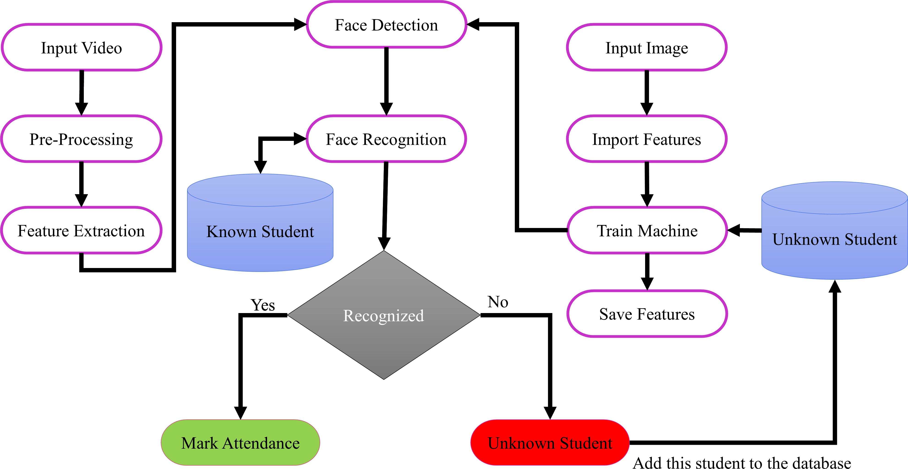

Figure 1: Your figure caption here
Figures in a scientific manuscript play a crucial role in visually presenting data, illustrating con- cepts, and enhancing understanding. When referring to figures in the manuscript, it’s essential to provide clear and concise descriptions to guide the reader through the content. Here’s how you can handle figures in your manuscript:
Figure Placement: Figures should be strategically placed within the text to complement and support the narrative. Typically, figures are inserted after they are first mentioned in the text or grouped together at the end of relevant sections or at the end of the manuscript.
Figure Numbering: Each figure should be assigned a unique number (e.g., Figure 1, Figure 2, etc.) and accompanied by a descriptive caption. Figure numbers should appear sequentially throughout the manuscript.
Descriptive Captions: Captions should be concise but informative, providing a brief title or de- scription of the figure’s content. Captions can also include additional details such as legends, labels, or explanations of symbols used in the figure.
In-Text References: When referring to a figure within the text, use the figure number (e.g., “Figure 1”) to direct the reader to the corresponding visual representation. For example, “As shown in Figure 1, the relationship between variables X and Y is evident.”
Consistency and Clarity: Ensure consistency in formatting and labeling of figures throughout the manuscript. Figures should be clear, legible, and appropriately sized to fit within the document.
Permissions and Citations: If the figures are adapted or reproduced from previously published sources, provide proper citations and obtain necessary permissions as per copyright guidelines.
Accessibility: Consider accessibility when creating figures, ensuring that they are comprehensible to readers with visual impairments. Provide alternative text descriptions for figures when necessary. Figure captions should be below the figures. Insert figures and tables after they are cited in the text. Use the ”Figure 1”, even at the beginning of a sentence. When placing more than two figures and photos under the same number of title, assign subtitles by dividing each figure and photo by (a) or (b). Do not use a shadow or frame around the figure. Multi-curve graphs should have individual curves marked with a symbol; the meaning of the symbol should be explained in the figure caption. Good quality black-and-white photographs or scanned images should be supplied for the illustrations.

Tables
Insert tables after they are cited in the text. Tables are referred to in the text by “Table n” (capital T). Table heads should appear above the tables. When placing more than two tables under the same number of title, assign subtitles by dividing each table by (a) or (b). For example: Table 1, Table 2(a) and 2(b). Avoid any colors or shadings in the table.

Table 1: adddd
A A A A A
b b b b b
c c c c c

Units
Use either SI (MKS) or CGS as primary units. (SI units are encouraged.) English units may be used as secondary units (in parentheses). An exception would be the use of English units as identifiers in trade, such as “3.5-inch disk drive.” Avoid combining SI and CGS units, such as current in amperes and magnetic field in oersteds. This often leads to confusion because equations do not balance dimensionally. If you must use mixed units, clearly state the units for each quantity that you use in an equation.

Some Common Mistakes
The word “data” is plural, not singular. In American English, periods and commas are within quotation marks, like “this period.” A parenthetical statement at the end of a sentence is punctuated outside of the closing parenthesis (like this). (A parenthetical sentence is punctuated within the parentheses.) A graph within a graph is an “inset,” not an “insert.” The word alternatively is preferred to the word “alternately” (unless you mean something that alternates). Do not use the word “essentially” to mean “approximately” or “effectively.” Be aware of the different meanings ofthe homophones “affect” and “effect,” “complement” and “compliment,” “discreet” and “discrete,” “principal” and “principle.” Do not confuse “imply” and “infer.” The prefix “non” is not a word; it should be joined to the word it modifies, usually without a hyphen. There is no period after the “et” in the Latin abbreviation “et al.” The abbreviation “i.e.” means “that is,” and the abbreviation “e.g.” means “for example.” An excellent style manual for science writers is [7].

Equations
Equations and formulae should be typed in Mathtype, and numbered consecutively with Arabic numerals in parentheses on the right hand side of the page (if referred to explicitly in the text). They should also be separated from the surrounding text by one space.

Conclusion
Talk about any qualifications important to your findings (all studies have weaknesses/qualifications). This includes alternative explanations for the results. For example, you might speculate about an unexamined third variable that was not present in you study. However, BE SPECIFIC and back up any assertions you make. For example, if you claim that 3rd variables might affect your correlations, tell me what they are and how they would affect your correlations. Speculate about future directions that research could take to further investigate your question. This might relate back to any weaknesses you have mentioned above (or reasons why the results did not turn out as expected). Future directions may also include interesting next steps in the research.

Supplementary Materials:
None or The following supporting information can be downloaded at: https: //www.mjs.com/, Pages S1–S10 (FTIR), Pages S11–S20 (1HNMR), Pages S21–S30 (MS), Pages S31–S33 inhibition zone, and Pages S34–S36 docking parameters.

Author Contributions
For research articles with several authors, a short paragraph specifying their individual contribu- tions must be provided. The following statements should be used “Conceptualization, X.X. and Y.Y.; methodology, X.X.; software, X.X.; validation, X.X., Y.Y. and Z.Z.; formal analysis, X.X.; investigation, X.X.; resources, X.X.; data curation, X.X.; writing—original draft preparation, X.X.; writing—review and editing, X.X.; visualization, X.X.; supervision, X.X.; project administration, X.X.; funding acquisition, Y.Y. All authors have read and agreed to the published version of the manuscript.” Authorship must be limited to those who have contributed substantially to the work re- ported.

Funding
Please add: ”None” or ”This research received no external funding” or ”This research was funded by NAME OF FUNDER grant number XXX.” and and ”The APC was funded by XXX”. Check carefully that the details given are accurate and use the standard spelling of funding agency names at https://search.crossref.org/funding, any errors may affect your future funding.

Data availability statements
None or We encourage all authors of articles published in MJS journal to share their research data. In this section, please provide details regarding where data supporting reported results can be found, including links to publicly archived datasets analyzed or generated during the study. Where no new data were created, or where data is unavailable due to privacy or ethical restrictions, a statement is still required.

Acknowledgments
In this section you can acknowledge any support given which is not covered by the author contribution or funding sections. This may include administrative and technical support, or donations in kind (e.g., materials used for experiments).

Conflicts of interest
Declare conflicts of interest or state “The authors declare no conflicts of interest.” Authors must identify and declare any personal circumstances or interest that may be perceived as inappropriately influencing the representation or interpretation of reported research results. Any role of the funders in the design of the study; in the collection, analyses or interpretation of data; in the writing of the manuscript; or in the decision to publish the results must be declared in this section. If there is no role, please state “The funders had no role in the design of the study; in the collection, analyses, or interpretation of data; in the writing of the manuscript; or in the decision to publish the results”[2].

Citation References
The template will number citations consecutively within brackets [3]. References should be cited by numbers in square brackets in the forms:[1, 4], [5]. They should be listed and numbered in their order of citation in the text, not by name and date [1, 3–6]. References should be in IEEE style. Refer simply to the reference number, as in [3]—do not use “Ref. [3]” or “reference [3]” except at the beginning of a sentence: “Reference [3] was the first . . .”. If there are six authors or more give all authors’ names; do not use “et al.”. Papers that have not been published, even if they have been submitted for publication, should be cited as “unpublished” [4]. Papers that have been accepted for publication should be cited as “in press” [5]. Capitalize only the first letter in the words in a paper title, except for proper nouns and element symbols. For papers published in translation journals, please give the English citation first, followed by the original foreign-language citation [6].

References
- F. Majeed, F. Z. Khan, M. Nazir, Z. Iqbal, M. Alhaisoni, U. Tariq, M. A. Khan, and S. Kadry, “Investigating the eﬀiciency of deep learning based security system in a real-time environment using yolov5,” Sustainable Energy Technologies and Assessments, vol. 53, 2022. DOI: 10.1016/j.seta.2022.102603.
- D. Sunaryono, J. Siswantoro, and R. Anggoro, “An android based course attendance system using face recognition,” Journal of King Saud University - Computer and Information Sciences, vol. 33, no. 3, pp. 304–312, 2021. DOI: 10.1016/j.jksuci.2019.01.006.
- P. N. Belhumeur, J. P. Hespanha, and D. J. Kriegman, “Eigenfaces vs. fisherfaces: Recognition using class specific linear projection,” IEEE Transactions on Pattern Analysis and Machine Intelligence, vol. 19, no. 7, pp. 711–720, 1997. DOI: 10.1109/34.598228.
- A. Generosi, T. Agostinelli, and M. Mengoni, “Smart retrofitting for human factors: A face recognition-based system proposal,” International Journal on Interactive Design and Manufacturing, vol. 17, no. 1, pp. 421–433, 2023. DOI: 10.1007/s12008-022-01035-4.
- L. Morales, C. A. Ouedraogo, J. Aguilar, C. Chassot, S. Medjiah, and K. Drira, “Experimental comparison of the diagnostic capabilities of classification and clustering algorithms for the qos management in an autonomic iot platform,” Service Oriented Computing and Applications, vol. 13, no. 3, pp. 199–219, 2019. DOI: 10.1007/s11761- 019-00266-w.
- P. Viola and M. J. Jones, “Robust real-time face detection,” International Journal of Computer Vision, vol. 57, no. 2, pp. 137–154, 2004. DOI: 10.1023/B:VISI.0000013087.49260.fb.

