Occupational Radiation Exposure to Workers Used18F-FDG
A.A. Wabdan^{1,2}, H.M. Yassinand M.S. El- Nagdy¹
¹Physics Department, Faculty of Science, Helwan University, Cairo, Egypt
NuclearMedicine Department, Faculty of Medicine, Cairo University, Cairo, Egypt
²Natural Sciences Department, Collage of Basic Education, Summer University, IRAQ
Correspondent Author Email: {A.A.Wabdan. ahmedngo@gmail.com}

Abstract
The increasing interest of medical institutes in the development of imaging services to include the hybrid system [Positron Emission Tomography combined with Computed Tomography(PET/CT)], this system is acquiring explosive growth due to its ability to accurately detect and stage many types of cancer and follow the progress of treatments. An increasing demand for use of (18F-FDG PET) in oncology has been the main reason for its growth. The physical characteristics of positron emissions result in higher radiation risk for staff and growing use of PET/CT for diagnostic purposes increase radiation exposure.
The objective of this study was to estimate the radiation exposure to the medical physicists, technicians and nurses working in three Egyptian nuclear medicine institutes under our investigations, based on the whole body collective dose measured by thermoluminescent dosimeters (TLDs) and the effective dose per study received by medical staff were measured by electronic pocked dosimeters and the finger doses by ring dosimeter during a period of six months. The (mean± SD) dose measured per PET/CT procedure were (2.45±0.137, 3.22±0.218 and 1.69±0.11) μSv for the medical physicist, technician and nurse respectively. The (mean± SD) dose measured per MBq of 18F-FDG were (7.35±0.43, 9.73±0.66 and 5.13±0.33) nSv/MBq for the medical physicist, technician and nurse respectively. The (mean± SD) finger dose measured per 18F-FDGPET/CT scans were (179.9±24.94, 8.82±2.912 and 24.15±4.164) μSv for the medical physicist, technician and nurse respectively.
Key Words: PET/CT, Radiation Dose, 18F-FDG.

Introduction

(PET/CT) is considered one of the most relevant diagnostic imaging techniques having the peculiar characteristic to provide both functional and morphological information of the organ of interest [1] PET/CT has become a widely accepted and frequently used imaging modality [2]. Combined PET/CT improves diagnostic accuracy in comparison with PET alone [3,4].PET/CT is most commonly performed with 18F-FDG, which has a half-life of 109.8 minutes. Fluorine-18 is a positron emitting radionuclide that leads to an annihilation reaction of a positron and electron, producing two 511 keV photons. The 511 keV annihilation photons are much more highly penetrating than other diagnostic radiations [5].
It has been known for many years that the radiation exposure to staff performing PET studies is higher than conventional nuclear medicine imaging [6,7].The increasing numbers of PET studies for routine diagnosis creates a real hazard to radiation workers[8]. Since new techniques of imaging are used and new measurements concerning the doses to medical staff are needed [9]This hasmotivated several studies for better perception of the radiation dose levels received by medical staffundertaking imaging with positron-emitter tracers[10,11,12].
The aim of this study was to measure the occupational radiation exposure of medical staff working in three Egyptian nuclear medicine institutes.
It has been necessary for staff to modify their working practices in order to minimize radiation exposure. After effective shielding of syringes, vials, transmission and quality control sources, attention has turned to minimizing the exposure to staff from patients. Education of staff on the importance of distance and time is a key factor in dose control.[5,13]

Materials and Methods

PET/CT Institutes: The present study was carried out in three nuclear medicine (NM) institutes in Cairo, Egypt , presenting significant differences in their layout and radiation protection issues, but employing only [18F]-FDG in their PET/CTexams.
Dosimeters:For measuring the whole-body dose and skin dose, medical workers were supplied with TLDs [100 TLD with lithium fluoride (LiF) detector annealed up to 3000C by Harshaw 6600 reader] and electronic pocked dosimeters [DoseRAE (ver2-04.07)] which having a dose sensitivity of [0μSv to 9.99 Sv (0μR to 999 R), dose resolution (≤ 0.02 μSv (≤ 2 μR)] worn at the upper pocket of their overall as shown in Figure 1. Prior to the measurements, all dosimeters had been calibrated at 660 keV with a 137Cs source in the Egyptian national institute for standards. Ring [gammas-ray, x-ray only <15kev photons; dose range 300 µSv to 10 Sv] dosimeters were employed to measure finger radiation doses to PET/CT staff. These dosimeters were particularly suitable for this investigation.
Individual Monitoring:In each 18F-FDG PET/CT image, one medical physicist, one nurse and one technologist worked together to cover their indicate duties.During each individual task, three (TLDs card, EPD, Ring) dosimeters were worn by medical staff: one for measuring the whole-body collective dose, secondfor measuring effective dose and third to measure finger radiation dose for each task dose. TLDs cards were read periodically every three months by Harshaw 6600 reader in the Egypt national institute for standardsand recorded the data through 6 months period of study, while the EPD [DoseRAE (ver2-04.07)] dosimeters were read monthly and recorded during period of study, ring dosimeters were worn for one months from all medical physicists, technicians, nurses similar to the whole-body measurement. However, we were able to measure finger doses of each PET/CT procedure to medical workers and recorded.In the three investigated nuclear medicine institutes, the procedure of setting up an intravenous line has been performed prior to administering the tracer to patient. The following tasks concerning PET/CT procedures were investigated:
1-Drawing up aradiopharmaceutical.
2-Injecting the radiopharmaceutical.
3-All PET/CT imaging (escorting, positing, acquiring images and helping the patient during and until the study is completed).
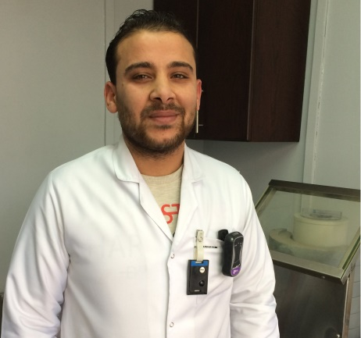
Figure 1: Example of positioning of the TLDs and EPD dosimeters.

Results and Discussion

- The Whole Body Collective Dose:Over 6-months for a total of 144 working days period of study, the whole-body collective doses of the PET/CT staff for three institutes involved in 18F-FDG PET/CT procedure were measured with the use of TLDs dosimeters and reported in Table 1 and the comparison between them is shown in Figures2,3,4.

Table 1:Dosimetric evaluation of the PET/CT staff in three institutes for a 6 months period measured by TLDs.
Institutes | No. of  Patients/  day | Administered activities/patient  MBq | Physicist  TLDs  (mSv)  (Mean±SD) | Technician  TLDs  (mSv)  (Mean±SD) | Nurse  TLDs  (mSv)  (Mean±SD)
Institute #1 | 4-6 | 300-350 | 1.91±0.014 | 2.64±0.17 | 1.2±0.113
Institute #2 | 8-12 | 275-315 | 2.4±0.14 | 3.15±0.16 | 1.73±0.08
Institute #3-3 | 13-15 | 333-355 | 2.81±0.071 | 3.61±0.099 | 1.99±0.042
Institute #3-4 | 13-15 | 333-355 | 2.77±0.042 | 3.58±0.084 | 2±0.084
#3-3 means: Third institute-first group.
#3-4 means: Third institute – second group.

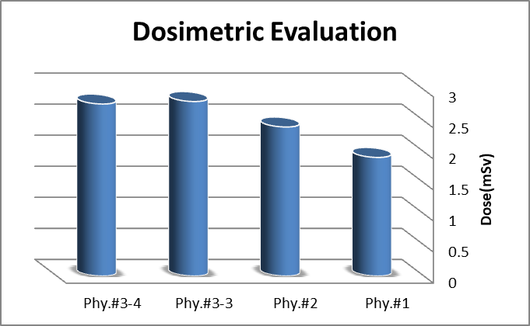
Figure 2:Dosimetric evaluation of the medical physicists in three institutes for a 6 months period measured by TLDs

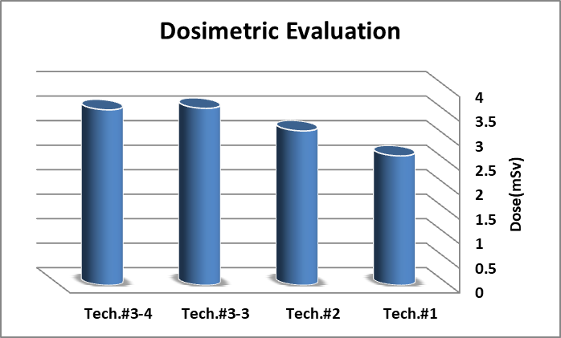
Figure 3: Dosimetric evaluation of the technicians in three institutes for a 6 months period measured by TLDs.

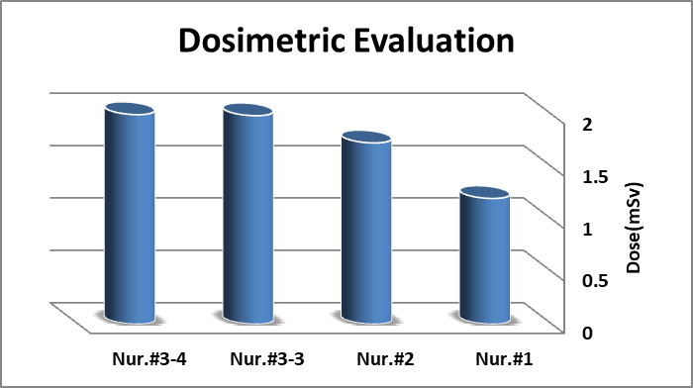
Figure 4: Dosimetric evaluation of the nurses in three institutes for a 6 months period measured by TLDs.

- Effective whole-body dose:Effective whole-body dose to nuclear medicine staffs in three institutes duringperforming duties with18F-FDG PET/CT procedureswere measured monthly with the use ofEPD during a 6 months period of study and reported in Table 2 and the comparison between them is shown in Figures 5,6,7:

Table 2: Dosimetric evaluation of the PET/CT staff in three institutes for a 6 months period measured by EPD.
Institutes | No. of  Patients/month  (Mean±SD) | Administrated activities/month  (GBq)  (Mean±SD) | Physicist  µSv/month  (Mean±SD) | Technician  µSv/month  (Mean±SD) | Nurse  µSv/month  (Mean±SD)
Institute #1 | 130±11.52 | 42.199±4.656 | 327.83±34.84 | 449.33±60.59 | 207.5±24.24
Institute #2 | 230.5±15.78 | 68.666±6.154 | 401.8±26.5 | 527.2±36.06 | 289.8±20.17
Institute #3-3 | 168±4.243 | 58.244±2.187 | 470.3±14.51 | 607.2±18.14 | 333.2±13.57
Institute #3-4 | 169.5±5.612 | 58.522±2.575 | 466.7±15.58 | 603.2±26.76 | 333.8±17.08
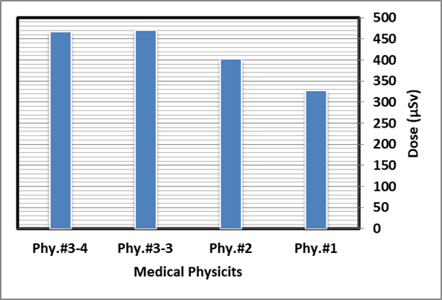
Figure 5: Dosimetric evaluation of the medical Physicists in three institutes for a 6 months period measured by EPD.

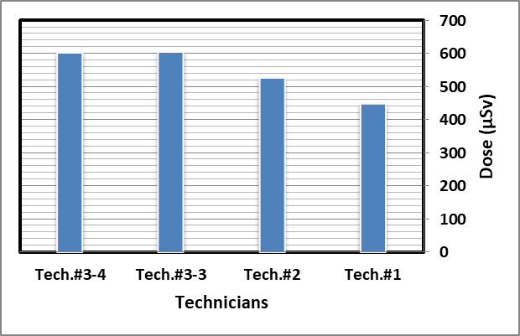
Figure 6: Dosimetric evaluation of the technicians in three institutes for a 6 months period measured by EPD

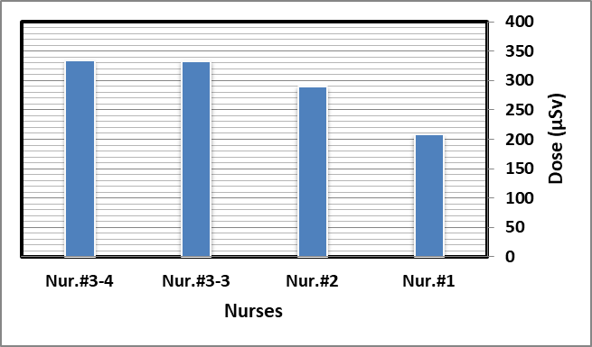
Figure 7: Dosimetric evaluation of the nurses in three institutes for a 6 months period measured by EPD.

- Finger doses:Finger radiation doses to the PET/CT staffs in three institutes during cover their indicate duties with18F-FDG PET/CT procedureswere measured during one month with the use ofring dosimeters and reported in Table 3 and the Comparison between them is shown in Figure8,9,10:

Table 3: Finger doses to nuclear medicine staffs in three institutes while performing duties with18F-FDG PET/CT procedures.
Institutes | No. of  procedures | Administrated activities  (MBq) | Physicist  µSv/study | Technician  µSv/study | Nurse  µSv/study
Institute #1 | 124 | 325±25 | 153.7 | 5.04 | 19.67
Institute #2 | 240 | 295±20 | 213.75 | 12.08 | 29.5
Institute #3-3 | 162 | 344±11 | 177.9 | 8.64 | 24.93
Institute #3-4 | 168 | 344±11 | 174.4 | 9.52 | 22.5

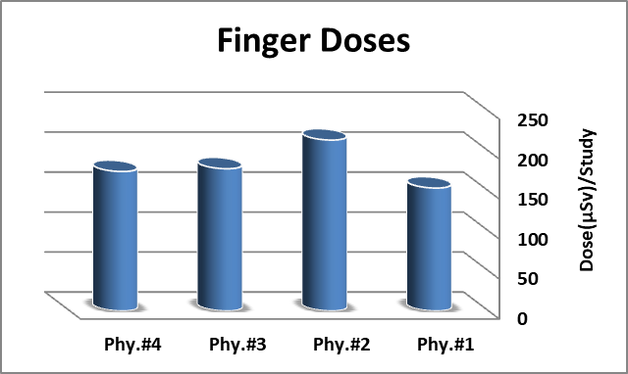
Figure 8: Finger doses of the medical physicists in three institutes during one month period measured by ring dosimeter

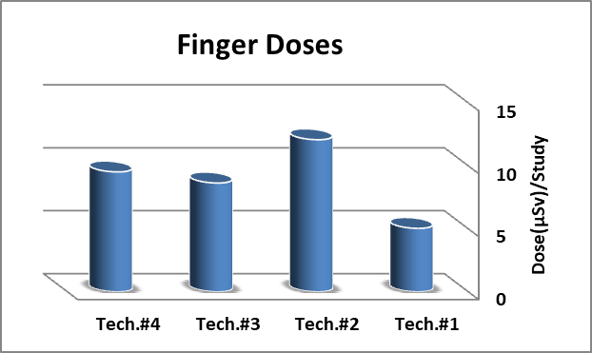
Figure 9: Finger doses of the technicians in three institutes during one month period measured by ring dosimeter

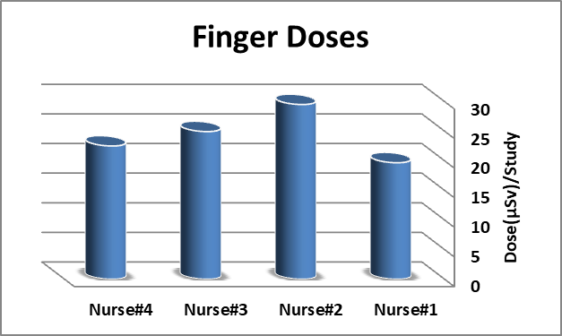
Figure 10: Finger doses of the Nurses in three institutes during one month period measured by ring dosimeter.

The radiation dose to the workers in PET/CT units mainly arises from handling of the 18F-FDG (preparation, injection) and from close contact to the patients after injection. The radiation exposure may be affected by many reasons such as the amount of the administered activity and the number of patients, mobility of patients and their physical health condition, workers experience, individual skills, training , imaging protocol and work practice.
International commission on radiological Protection 2007, recommendations of the international commission on radiological protection (ICRP) Publication 10320 mSv per year for whole-body and 500 mSv per year for fingers[14].
There were several reports on whole-body dose per study in the literature; such as 8.9 μSv by Zeffet al. ,8.5 μSv by Chiesa et al., 6.5 by Benetaret al., and 7.2 μSv by Biranet al. .
It is difficult to compare these doses between institutes because of the variability in the condition factors in each individual PET/CT facility, such as the patient doses, the procedure, the staff performance and shielding devices.
In three nuclear medicine institutes, technician was the highest radiation dose compare with another medical workers and this increasing due to the longer time spent near the patientsduring all PET/CT imaging tasks.
Finger doses were found to be within permissible limits. The highest finger dose to physicist are likely from handing of the 18F-FDG multi-dose syringe, transferring the dose to the injection room and measuring the post-injection residual dose in the syringe. The nurse performed shorter part with ready-made individual radiopharmaceutical syringe and pre IV for administration. Although, technician spent the maximal time per study, however, they have the lowest finger dose because they did not directly handle the radioactive material.
An understanding of the radiation protection and safety issues are very important to keep clinical and occupational exposure as low as reasonably achievable (ALARA) [15].

Conclusions

When compared with the ICRP dose limit,each individual worker can work with many more 18F-FDG PET/CT studies for a (period time) without exceeding the occupational dose limits.
This study confirmed that low levels of radiation doses are received by our medical staff involved in 18F-FDG PET/CT procedures

ACKNOWLEDGMENTS
The authors would like to thank: Professor Magdy Hafez, director of the cyclotron in hospital 57for technical support; the physicists Ahmed Ibrahim, Ahmed El Shazly, Shibl Mohammed and all the staff members of PET/CT institutes in Egypt, for their help in all steps needed to complete this work and for the time they kindly afforded in order to respond to all my questions.

References
- Dalianis, K., et al. "Dosimetric evaluation of the staff working in a PET/CT department." Nuclear instruments and Methods in Physics Research Section A: Accelerators, Spectrometers, Detectors and Associated Equipment 569.2 (2006): 548-550.‏
- Townsend DW, Carney JPJ, Yap JT, et al: PET/CT today and tomorrow. J Nucl Med 45:4S-14S, 2004.
- Charron M, Beyer T, Bohnen NN, et al: Imaging analysis in patients
with cancer studied with a combined PET and CT scanner. ClinNucl
Med 25:905-910, 2000
- Wahl RL: Why nearly all PET of abdominal and pelvic cancers will be
performed at PET/CT. J Nucl Med 45:82S-95S, 2004
- Bixler A, Springer G, Lovas R: Practical aspects of radiation safety for using fluorine 18. J Nucl Med Technol 27:14-16, 1999.
- Chiesa C , De Sanctis V , Crippa F , et al. Radiation dose to technicians per nuclear medicine procedure: comparison between technetium-99m, gallium-67, and iodine-131 radiotracers and fluorine-18 fluorodeoxyglucose. Eur J Nucl Med. 1997 Nov;24(11):1380-9.
- Roberts F.O, Gunawardana D.H, Pathmaraj K, et al. Radiation dose to PET technologists and strategies to lower occupational exposure. J Nucl Med Technol 2005; 33:44-47.
- Demir, Mustafa, et al. "Radiation doses to technologists working with 18F-FDG in a PET center with high patient capacity." Nukleonika 55 (2010): 107-112.‏
- Amaral A, Itie C, Bok B, Dose Absorbed by Technicians in Positron Emission Tomography Procedures with FDG, Brazilian Archives of Biology and Technology 50: pp.129-134, Semptember 2007.
- Wu, T.H., Liu, R.S., Chong, N.S., et al (2000), Evaluation of equivalent dose to work staff with Oxygen-15-watrer in positron emission tomography
studies. ApplRadiatIsotop, 53, 463-468.
- Schleipman A.R., Castronovo, F.P. Jr, Di Carli, M.F., Dorbala, S. (2006), Occupational radiation dose associated with Rb-82 myocardial perfusion positron emission tomography imaging, J NuclCardiol, 13 (3), 378-384.
- Seierstad, T., Stranden, E., Bjering, K., Evensen, M., Holt1, A., Michalsen, H. M., Wetteland, O. (2007), Doses to nuclear technicians in a dedicated PET/CT centreutilising 18F fluorodeoxyglucose (FDG), RadiatProtDosim, 123 (2), 246-249.
- Brown TF ,Yasillo NJ. Franklin Mclean. Radiation safety considerations for PET centers. J Nucl Med Technol. 1997 Jun;25(2):98-102.
- Protection, R. (2007). ICRP publication 103. Ann. ICRP, 37(2.4), 2.‏
- H.M. Yassin , M. S. El-Nagdy , A. Wabdan; Radiation Protection and Dosimetry for worker used 18F-FDG,EJNM & MI (2017)44(Suppl. 2):S452-453.

