Biodegradable plastic production by Bacillus spp. isolated from agricultural wastes and genetic analysis of PHA synthesis

Dr. Neihaya Heikmat Zaki
Department of Biology, College of Science, AL-Mustansiriyah University
E.mail: neihaya_2008@yahoo.com or dr.neihayahz@uomustansiriyah.edu.iq

Abstract
Polyhydroxyalkanoates (PHAs) are resources that hoard by a variety of microorganisms as nutrient source. It is environmentally recyclable biopolymer, and totally corrupted biologically to simple molecules.
A total of 38 isolates from agricultural wastes, 9 isolates exhibited optimistic outcome (dark blue particles) for PHA accumulation when stain by Sudan black B. Maximum bacterial growth was achieved at temperature 35°C, PH 7, (48-72) hr incubation and 0.25% concentration of NaCl. Chosen isolate (NE1MOK) recognized as Bacillus subtilis when diagnosed by traditional and molecular methods by amplification 16s rRNA gene. Bacillus subitilis had ability to accumulate 0.26 g/l (40.625 %) of PHA, and characterized by Fourier transforms infrared (FTIR) analysis which exhibited functional groups of PHA as (C-O, C=O, CH₂, CH₃, C-O-C, C-H and terminal OH). PCR results for amplification of synthase genes showed positive results in all isolates and length of amplicons was 505 bp. The aim of this study was to use agricultural wastes as a source to select bacterial isolates which produce PHAs, and determined the optimal conditions of bacterial growth, then analyze the genes responsible of its formation.

Key words: Bacillus spp., PHA production, FTIR, Characterization, synthase genes.

Introduction
Today, synthetic polymer has become indispensable part of our life. Petrochemical materials used to manufacture synthetic polymer and plastic, they are defiant to biodegradation, which poses a grave menace to the surroundings (1). Environment issue due to pollution increases in the price of petroleum and depletion of fossil fuels makes us to develop bioplastic as a substitute for petrochemical derived plastic (2).

polyhydroxyalkanoates (PHA) has become substitute for petrochemical derived plastic due to similar mechanical properties, PHA is ecofriendly, biodegradable, biocompatible and microbial thermoplastic (3). PHA is a homopolymer straight chain of D-β-hydroxyalkanoates, is produced as granules in different bacteria (4). PHA synthesis occurs during exponential growth phase and transferred into important energy reserves (5).
Biosynthesis of PHA occurred when quantity of necessary nutrients as nitrogen or phosphorus limiting, while carbon abounding is overload (6). Alcaligenes, Pseudomonas, Bacillus, Rhodococcus, Staphylococcus and Micrococcus are some bacterial species, which naturally produce PHA (7). Gram-negative bacteria accumulated PHA and used broadly in a range of products. PHA from Bacillus species are extensively used in biopharmaceutical applications after lack Lipopolysaccharides from its membrane (8). Also PHA considered as eco-friendly bioplastics when used in industrial application (9).
PHA genes coded to proteins in biosynthetic pathways, like phaA, phaB, and phaZ that coded to ketothiolase, reductase, and depolymerase, respectively, have revealed to take place in pha gene clusters (10). Recent methods have developed to make PHAs from industrial, agricultural, food, municipal wastes and sludge of paper and pulp mills. Therefore, substitute of non-biodegradable with biodegradable plastic from organic waste can supply many profit to the environment and add to sustainable development (11). Therefore, our aim was to determine the optimal conditions of bacterial growth and produce PHA from bacteria isolated from agriculture wastes, then amplification of synthase genes by PCR technique.
Materials and Methods
Collection of Samples and bacterial isolation
Samples collected from agricultural wastes in gardens of Baghdad University under a septic condition using standard practices (12). Isolation of bacteria from wastes was done by serialized dilution (to 10⁻⁶), then bacterial isolation done by used pour plate technique on nutrient agar (Hi media, India). Plates incubated for 24 h at 37 ˚C.
Screening for PHA-producing bacteria
PHA producing bacteria detected by using the lipophilic Sudan black B stain (ethanol 0.3%) according to (13).
Effect of various growth parameters on Bacterial growth
Several cultural parameters like salt concentration (NaCl=0.25, 0.5, 1, 2.5, 5%), incubation time (24-120 h), pH (4-9), and temperature degree (25°C-50°C) were evaluated to establish their effect on bacterial growth (14). Briefly, tubes with Nutrient broth were accustomed with each parameter, and inoculated with bacterial culture then incubated in shaking incubator (150 rpm). Culture observed by spectrophotometer and measured the O.D at 600 nm.
Bacterial PHA production
Bacteria spp. inoculated in production media containing of: yeast extract (2.5 g/l), tryptone (4.0 g/l), glucose (1% w/v), and sodium chloride (0.25 g/l). 2% (v/v) inoculum added to production medium (100 ml) then incubated in a shaker (150 rpm) at 35° C for 48 h (15).
Cell dry weight:
After incubation, bacterial culture centrifuged (10,000 rpm) for 15min. Cell pellet dried to determine dry cell weight (DCW) as g/l unit (16).
PHA extraction
It performed by sodium hypochlorite-chloroform method according to (12).
Quantification of PHA
PHA was liquefied in chloroform and evaporated completely, and determined as dry weight in unit of g/l (17). Percentage of produced PHA was calculated according to the equation:
Accumulation of PHA (%) = Dry weight of PHA (g/l)/ Dry cell weight (g/l) × 100

Characterization of polymer by FTIR
FTIR spectrum was taken using Fourier Transform IR Spectrophotometer (Schimadzu-8400s). The spectra were recorded in range of 4000-500 cm⁻¹.

Identification of PHA –producing bacteria
1-Biochemical tests: Many biochemical tests achieved to detect PHA producing bacteria (18).
2-Molecular identification
DNA extraction:
DNA extraction of bacteria was done using Genomic DNA purification Kit (Wizard®) according to the manufacturing of the company. The purity of DNA checked by nanodrop (promega), and the range was between (50-100 np) (11).
Selection of Primers:
PCR amplification were done by using the primers (Alpha DNA, USA) which specific for 16sRNA for Bacillus spp. according to the manufacture companies' information (Advanced Scientific Bureau), Primer sequence listed in (Table-1).
Table-1: Primer sequence of 16sRNA for Bacillus spp.
Gene name | Primer sequence
16sRNA | F 5- GGTGGAGCATGTGGTTTA-3
16sRNA | R 5- CCATTGTAGCACGTGTGT-3

Amplification reaction
In the present study, 30 cycle of amplification used, for all genes the cycling conditions were applied according to (11) with modification (Table-2).
Condition | Initial  Condition | Cycle  no. | Denaturation | Annealing  of primer | Elongation | Final  extension
primer
16sRNA | 94°C/min | 30 | 94°C/sec | 58°C/30sec | 72°C | 72°C
Table-2: conditions of amplification reaction of PCR

Electrophoresis by agarose gel
PCR products were evaluated by electrophoresis as method of (19). DNA ladder (1000 bp) was the marker of the procedure, and power supply established at 7 V/cm for 2 hours. Gel exhibited by UV-Transilluminator then it’s photographed.
16S rRNA gene Sequencing
PCR products were purified by extraction kit (GenElute™ gel-Sigma). Sanger sequencing method was used in sequencing PCR product according to (20).
Universal primers were chosen to gene sequence by sequencing Ready Reaction Kit (Applied Biosystems, USA). In National Centre for Biotechnology Information (NCBI) the chromatogram was prepared by Chimeras 5.2 software.

Molecular analysis for synthase genes of PHA
Template Preparation
Phenol- chloroform extraction method used as the first stage to extract template according to (12). Then supernatant removed to other tube. In the following stage, Isopropanol (0.6 volume) was added and mixed lightly until a tough white DNA precipitate made. Latest, the suspension centrifuged at 10000 rpm for 5 min and the pellet dried until ethanol completely evaporated, then TE buffer (30 μl) added, and DNA stored at -20˚C.
Primers descriptions
Two primers used for amplification of synthase genes in PHA producing bacteria (12). Complete characteristics showed in Table-3.

Table- 3: Descriptions of synthase genes

Gene name | Sequence of nucleotides
Class1- F | 5´-ATGAAAGAGGTTGTAATCGTCGCT-3´
Class1-R | 5´-TCAACGCTCCACTGCGAG-3´
Class2-F | 5´-ATGAGCAATCAACGAATTGCA-3´
Class2-R | 5´-TCATTGCATGTTCAGACCGC-3´

PCR conditions
Reaction mixture of PCR had 5μl of each (primer, template DNA, PCR buffer, MgCl2), 2 μl of DNA polymerase and 1.2 μl of DNTPs. Cyclic conditions were (95⁰C for 5 min used as initial denaturation, 35 cycles of denaturation at 95⁰C for 2 min, 60⁰C for 30 sec used to annealing, 72⁰C for 2 min and for 10 min used to extension and a final extension respectively), then embrace at 4⁰C (21).

Results and discussion
Isolation of PHA-producing bacteria
From 38 samples of agricultural wastes, nine isolates were exhibited dark blue particles after staining by Sudan black B (Fig.1). Agricultural wastes have organic materials with good values of biological oxygen demand (BOD) and carbon oxygen demand (COD), which effect on growing of bacteria, take nutrients of the wastes and change it to expensive products (22). (12) demonstrated that marine and organic-wastes can produce bioplastic from 32 isolates, while (11) showed that 42 isolates of PHA producers when stained by Sudan black B exhibited black-blue particles.

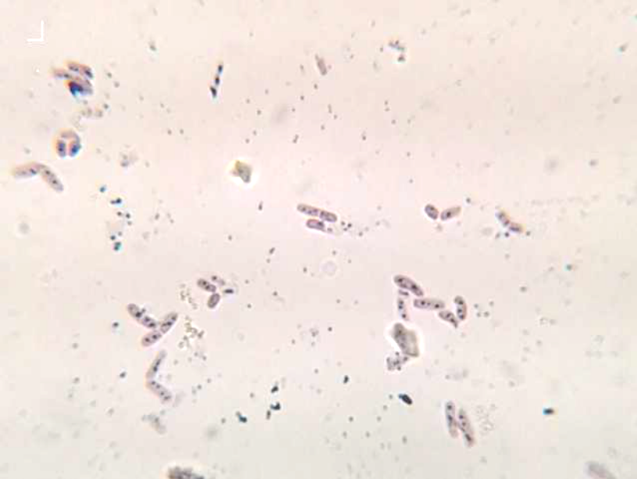
Figure-1: Bacillus spp. with Sudan black B stain

Effect of different parameters on bacterial growth
Effect of Temperature on Bacterial growth
Maximum bacterial growth was achieved at temperature 35 °C as shown in Figure-2. High or low temperatures effect on cell biomass and PHA synthesis by Bacillus subtilis may lead to decrease on PHA polymerase enzyme activity (23).

Figure-2: Temperature effect on growth of bacteria

Effect of incubation time on Bacterial growth
The incubation time was showing optimum bacterial growth at 48-72 hr for all the strains. The incubation time was exhibited in Fig.-3.

Figure-3: Incubation time effect on bacterial growth

After 72 h micronutrients were decreased, and there was increase in metabolites, this showed depressing result on bacterial growth and lead to decrease in PHA production (24).

pH effect on growth of bacteria
Low and high pH decreased the bacterial growth, while pH 7 was optimum to growth as in Fig. 4.

Figure-4: pH effect on growth of bacteria

In general, slight changes in pH affected on metabolic process of bacteria. (25) Exhibited that pH range from 6.5–7.5 caused greatest PHA production by B. sphaericus, while higher pH value decreased the production and this owing to its effect on the enzymes which degraded bioplastic.

NaCl effect on Bacterial growth
Concentration of 0.25% was the optimum concentration of Nacl to bacterial growth (Fig.-5). While the increase concentration of the salt due to decrease the growth. (17) Exhibited that concentration of 0.1% NaCl was appropriate for PHA bacterial producers.

Figure-5: NaCl Concentration effect on Bacterial growth

PHA Quantification
Bacillus subitilis was able to produce 0.26 g/l (40.625 %) of PHA (Fig.6). (26) Showed that highest PHA production from the bacteria Bacillus brevis M6 was (41.67% w/v), while (27) exhibited that PHA product from the bacteria P. corrugata A.1 was 1.93 g/L (47.3 %).
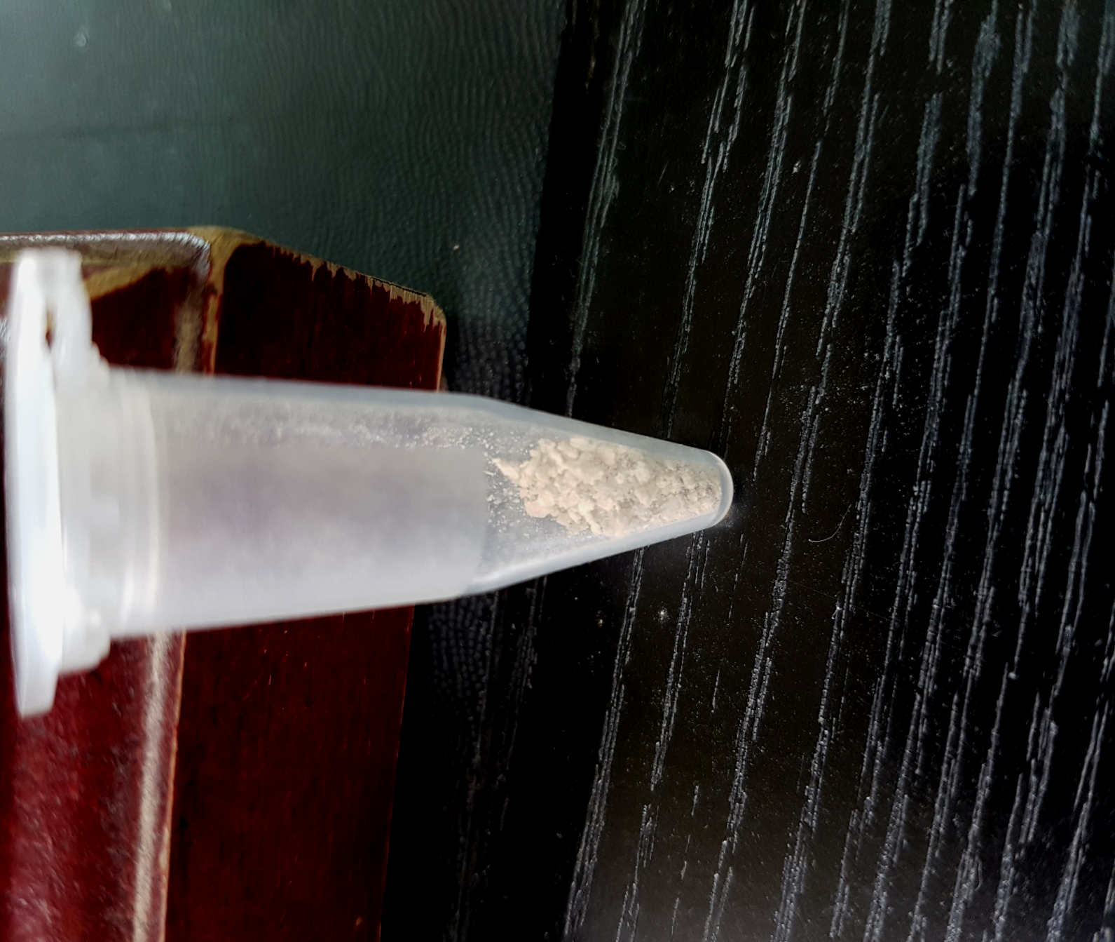
Figure-6: PHA polymer after extraction and drying
Polymer analysis by FTIR
(Fig.-7) shows the functional groups present in the structure of PHA. It exhibited bands at 1286.56 and 1730.21 cm⁻¹ which related to C-O and C=O groups. Bands for –CH₂, CH₃, and C-O-C groups occurred at 1411.94 cm⁻¹,1357.58cm⁻¹, and 1178.55 cm⁻¹. The absorption bands at 1566.25 and 3308.03 cm⁻¹ related to C-H and terminal OH groups. These results related to (28) who showed the characteristic peaks at (1226.77, 1454.38 and 1726.35) cm⁻¹ corresponds to the (C-O, C-H and C=O) respectively, and refer to functional groups present in the structure of pure PHA.

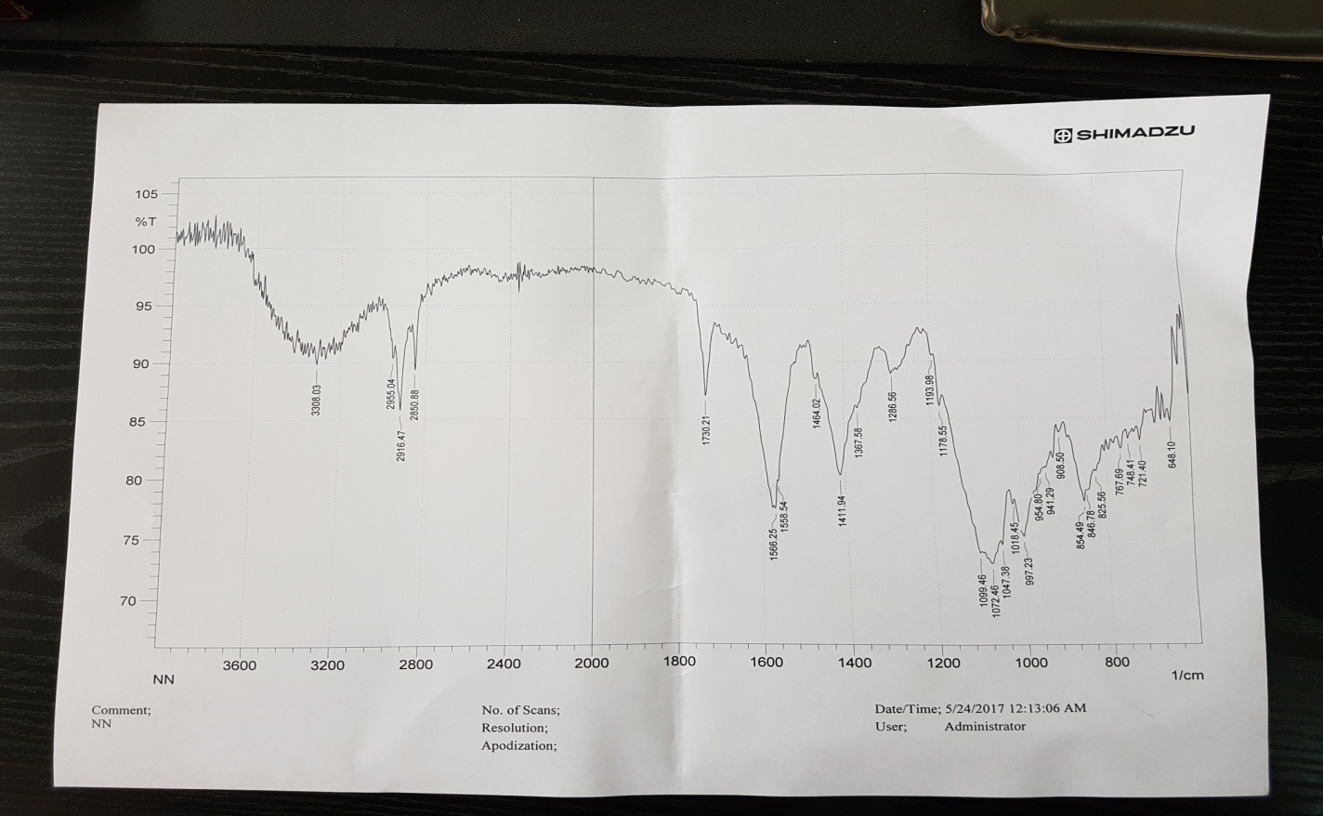
Figure-7: FT-IR Spectrum of PHA produced by Bacillus spp.

Biochemical and molecular characterization of PHA–producing bacteria
The selected isolate were identified as Bacillus sp. according to morphological and biochemical characterization (Table-4).

Table-4: Morphological and Biochemical characteristics of Bacillus isolate
Morphological character | Result
Color of colony | White
Texture of colony | Smooth
Gram stain | Positive
Shape of cell | Rod
Spore formation | Positive
Biochemical test | Result
Catalase | Positive
Indole test | Positive
MR-test | Negative
VP-Test | Negative
Citrate utilization test | Negative
H₂S test | Positive

PCR performed by using 16s rRNA primer for Bacillus spp. From results it found in 100% of tested isolates and the product size was (303 bp) compared to the ladder (Fig.8), and the strain NE1MOK was identified as gram positive Bacillus subtilis.

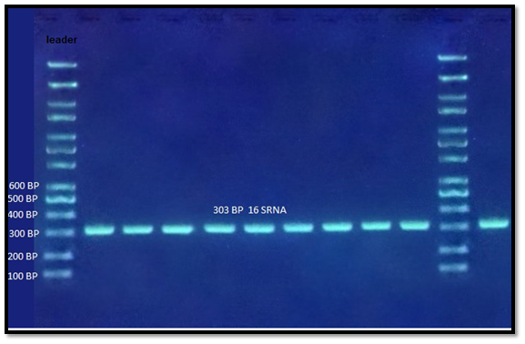
Fig.8: Amplification of 16S rRNA for Bacillus spp. (1.5% agarose, 7V/cm, for 120 min).
(3) Exhibited that 15 isolates of Bacillus sp. NA10 accumulated PHA from cardboard industry waste water, while (26) showed that 29 isolates of Bacillus from soil in Turkey could accumulate PHB.
After NE1MOK isolates was identified and confirmed as Bacillus subtilis, this sequence matched with bacterial sequences existing in GenBank database (Fig.-9). Sequence of this species is 100% similarity with B.subtilis according to GenBank: KX840010.1.

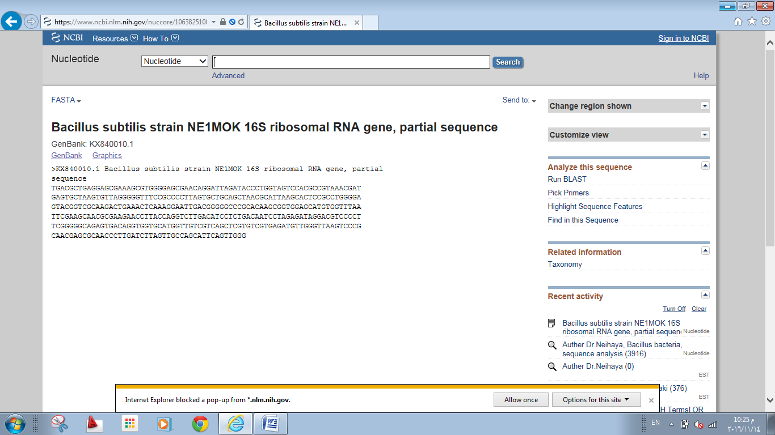
Figure-9: Sequence of 16s rRNA gene of B.subtilis NE1MOK

(29) used S4 isolate to show relation to Bacillus aryabhattai (similarity was 99.70%) based on 16S rRNA sequences, which could produce PHA. (30) also used 16S specific primers for samples, and analyzed phylogenetically to detect Bacillus subtilis.

Molecular analysis for synthase genes
Products of PCR were showed both class I and II PHA synthase genes in all tested isolates, and the length of PCR amplicons expected of 505 bp of PHA synthase (Fig.-10).
According to related searches, these two genes were accountable for the synthesis of PHA accumulation. (31) showed that all PCR amplicons of PHA synthase possessed the expected length of 551 bp.

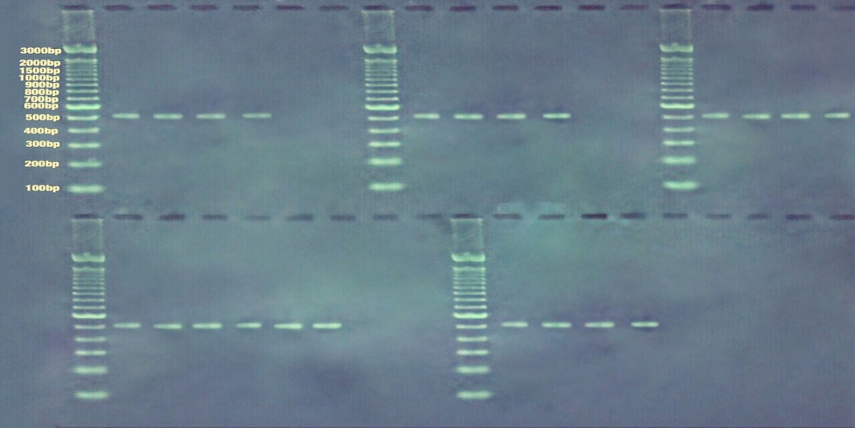
Figure-10: PCR results of PHA synthase genes of Bacillus subtilis

If soil bacteria have the potency to accumulate PHA, then over-expressed of bioplastic genes were increased the production of PHA (12). Azotobacter spp. could produce PHA, and genes accountable of PHA synthesis were recognized. But regulation of the genetic expression of these genes was very strong in the bacteria and also little (32).

Conclusion
At present, bacteria showed high ability to accumulate biodegradable plastic particles inside their cells, so researches focusing on developing methods to isolate producing bacteria from natural sources. Among 9 selected isolates from agricultural wastes, NE1MOK strain belongs to Bacillus subtilis has the ability to produce (0.26 g/l (40.625 %) of PHA. Also numerous physical parameters (Temperature, pH, Time incubation and Nacl concentration) affected on bacterial growth. Synthase genes (505 bp) were accountable for PHA synthesis in all isolates of producing bacteria.

Acknowledgment: The author would like to thank Al-Mustansiriyah University (www.uomustansiriyah.edu.iq), in Baghdad/ Iraq for its support in this work.

References
1-Tripathi, D.; Yadav, A.; Jha, A. and Srivastava, S. 2012. Utilizing of Sugar Refinery Waste (Cane Molasses) for Production of Bio-Plastic under Submerged Fermentation Process. J. Polym. Environ., 20: 446–453.

2-Radhakrishnan, M.; Vijayalakshmi, G. and Balagurunathan, R. 2014. Optimization of polyhydroxyalkanoates (PHA) production from marine Carnobacterium sp E3. Journal of Chemical and Pharmaceutical Research, 6 (12): 390-393.

3-Cruz-Pradella, J.; Ienczak, J.; Delgado, C. and Taciro, M. 2012. Carbon source pulsed feeding to attain high yield and high productivity in poly (3-hydroxybutyrate) (PHB) production from soybean oil using Cupriavidus necator. Biotechnol. Lett., 34: 1003–1007 .

4- Gupta, S.; Rajput, Y.; Shit, S.; Shukla, A.; and Shukla, K. 2011. Screening and production of bioplastic (PHAs) from sugarcane rhizospheric Bacteria. International Multidisciplinary Research Journal, 1(9): 30-33.

5- Charen, T.; Vaishali, P.; Kaushalya, M.; Amutha, K.; Ponnusami, V. and Gowdhaman, D. 2014. Isolation and identification of Polyhydroxybutyrate producing bacterial strain (Bacillus thuringiensis GVP) from chlorine contaminated soil. International Journal of ChemTech Research. 6(5): 3197-3202.

6- Gao, X.; Chen, J.C.; Wu, Q. and Chen, G. 2011. Polyhydroxyalkanoates as a source of chemicals, polymers and biofuels. Curr. Opin. Biotechnol. 22:768–774.

7- Lazarevic, D.; Aoustin, E.; Buclet, N. and Brandt, N. 2010. Plastic waste management in the context of a European recycling society: comparing results and uncertainties in a life cycle perspective. Resour. Conserv. Recycling, 55:246–259.

8- Nath, A.; Dixit, M. and Bandiya, A. 2008. Enhanced PHB production and scale up studies using cheese whey in fed batch culture of Methylobacterium sp. ZP 24. Bioresource Technol. 99:5749–5755

9- Ramadas, N.; Sindhu, R.; Binod, P. & Pandey, A. 2012. Development of a novel solid-state fermentation strategy for the production of poly-3-hydroxybutyrate using polyurethane foams by Bacillus sphaericus NII 0838, Ann. Microbiol., 63: 1265–1274.

10-Gabriel, J. M. and Maura, C. C. 2001. Phac and phar are required for polyhydroxyalkanoic acid synthase activity in Bacillus megaterium. Journal of bacteriology, vol. 183(14): p. 4235–4243.

11-Bhuwal, A.; Singh, G.; Aggarwal, N.; Goyal, V. and Yadav, A. 2013. Isolation and Screening of Polyhydroxyalkanoates producing Bacteria from Pulp, Paper, and Cardboard Industry Wastes. International Journal of Biomaterials. 1:(9),pp. 1-11.

12- Bhagowati, P. 2013. Bio-degradable plastic production by bacteria isolated from marine environment and organic-waste. A thesis submitted to national institute of technology, Rourkela.

13- Singh, P. and Parmar, N. 2011. Isolation and characterization of two novel poly-hydroxybutyrate (PHB) - producing bacteria. African J. Biotechnol., 10: 4907–4919.

14-Masood, F.; Hasan, F.; Ahmed, S. and Hameed, A. 2011. Biosynthesis and characterization of poly (3-hydroxybutyrate-co-3-hydroxyvalerate) from Bacillus cereus FA11 isolated from TNT-contaminated soil. Ann. Microbiol., 62: 1377-1384.

15- Ali, W.S.; Zaki, N.H.; and Obiad, Y.N. 2017. Production of bioplastic by bacteria isolated from local soil and organic wastes. Current Research in Microbiology and Biotechnology. Vol. 5 No. 2 : 1012-1017

16-Du, G.; Chen, J.; Yu, J. and Lun, S. 2001. Continuous production of poly-3-hydroxybutyrate by Ralstonia eutropha in a two stage culture system. J. Biotech. 88: 59-65.

17- Mikkili, I.; Karlapudi, A.; Venkateswarulu, T.C.; Babu, D.; Nath, S.; and Vidya, P. 2014. Isolation, Screening and Extraction of Polyhydroxybutyrate (PHB) producing bacteria from sewage sample. International Journal of PharmTech Research. 6(2): pp 850-857.

18- Holt, J. G., Krieg, N. R., Staley, J. T., & Williams, S. T. 2009. Bergey’s Manual of Determinative Bacteriology. 9th edition (Lippincot, William and Wilkins), USA.

19-Sambrook, J.; Fritsch, E.F.; and Maniatis, T. 2003. Molecular cloning: a laboratory manual. 2ed. NY, Cold Spring Harbor Laboratory Press.

20-Mirac, Y.; Haluk, S.; and Yavuz, B. 2004. Determination of poly-β-hydroxybutyrate (PHB) production by some Bacillus spp. World J. Microbiol. Biotechnol. 21:565–566.

21-Galehdari, H.; Alaee, S.; Mirzaee, M.; 2009. Cloning of poly (3-Hydroxybutyrate) synthesis genes from Azotobacter vinelandii into Escherichia coli. Jundishapur Journal of Microbiology. 2(1): 31-35.
22-Dias, J.M.; Lemos, P.C.; Serafim, L.; Oliveira, E.; Albuquerque, M.; Ramos, M.; Oliveira, R.; and Reis, M. 2006. Recent advances in polyhydroxyalkanoate production by mixed aerobic cultures: from the substrate to the final product. Macromol. Biosci. 6:885–906.

23-Tamdoğan, N.; Sidal, U. 2011. Investigation of poly-β-Hydroxybutyrate (PHB) production by Bacillus subtilis ATCC 6633 under different conditions. Kafkas Univ. Vet. Fak. Derg. 17(Suppl A):173–176.

24- Khanna, S. and Srivastava, A. 2005. Recent advances in microbial poly-hydroxy-alkanoates. Process Biochem. 40:607–619.

25- Flora, G.; Bhatt, K.; and Tuteja, U. 2010. Optimization of culture conditions for poly-β-hydroxybutyrate production from isolated Bacillus species. J. Cell Tissue Res. 10:2235–2242.

26-Singh, G.; Mittal, A.; Kumari, A.; Goyal, V.; Yadav, A.; and Aggarwal, N. 2013. Cost effective production of poly-β-hydroxybutyrate by Bacillus subtilis NG05 using sugar industry waste water. J. Polym. Environ. 21:441–44.

27- Palmeri, R.; Pappalardo, F.; Fragala, M.; Tomasello, M.; Damigella, A.; Catara, A. 2012. Polyhydroxyalkanoates (PHAs) Production through Conversion of Glycerol by Selected Strains of Pseudomonas Mediterranea and PseudomonasCorrugata. Chemical engineering transactions. 27:121-126.

28- Shah, K. R. 2012. FTIR analysis of polyhydroxyalkanoates by novel Bacillus sp. AS 3-2 from soil of Kadi region, North Gujarat, India. J Biochem Tech., 3(4): 380-383.

29- Tanamool, v. Tsuyoshi, I.; Danvirutai, P.; and kaewkannetra, P. 2013. Biopolymer generation from sweet sorghum juice: screening, isolation, identification, and fermentative polyhydroxyalkanoate production by Bacillus aryabhattai. Turk j. biol. 37: 259-264.

30- Singh, R. 2014. Isolation and characterization of efficient poly-hydroxybutyrate (PHB) synthesizing bacteria from agricultural and industrial land. Int.J.Curr.Microbiol.App.Sci. 3(6): 304-308.

31- CIESIELSKI, S.; POKOJ, T.; MOZEJKO, J. and KLIMIUK, E. 2013. Molecular Identification of Poly-hydroxy-alkanoates-Producing Bacteria Isolated from Enriched Microbial Community. Polish Journal of Microbiology, 62(1): 45–50.

32-Nikel, P.; Pettinari, M.; Galvagno, M.; and Méndez, B. 2006. Poly (3-hydroxybutyrate) synthesis by recombinant Escherichia coli arcA mutants in microaerobiosis. Applied Environmental Microbiology. 72: 2614-2620.

إنتاج البلاستيك القابل للتحلل من قبل عصيات ال Bacillus المعزولة من المخلفات الزراعية والتحليل الوراثي لتكوين ال PHA

الخلاصة
بولي هيدروكسي الكانواتس (PHA) هو من المواد التي تستخدم من قبل مجموعة متنوعة من الكائنات الحية الدقيقة كمصدر للمغذيات. وهو بيوليمر قابل لإعادة التدوير بيئيا، ويتحلل تماما بيولوجيا لجزيئات بسيطة.
من مجموع 38 عزله من المخلفات الزراعية ، 9 عزلات اظهرت نتيجة واضحة (جزيئات زرقاء غامقة) من تراكم PHA عند صبغها بصبغة سودان السوداء. وظهر اعلى نمو للبكتريا عند درجة حرارة 35م، اس هيدروجيني 7، حضن لمدة (48-72) ساعة و 0.25٪ من تركيز كلوريد الصوديوم. تم اختيار العزلة المسماة (NE1MOK) المعروفة على انها عصية Bacillus subtilis عندما تم تشخيصها بواسطة الطرائق التقليدية والجزيئية عن طريق التضخيم لجينات 16 Sالرايبوسي. وكانت Bacillus subtilis قادرة على تراكم 0.26 غرام / لتر (40.625٪) من PHA ، والذي شخص بجهاز مطياف الأشعة تحت الحمراء واظهر مجاميع وظيفية لل PHAمثل (C-O، C=O، CH2، CH3، C-O-C ، C-H و OH). كما أظهرت نتائج تضخيم جينات انزيم سينثيز نتائج إيجابية لجميع العزلات وكان طول الامبليكونس 505 زوج قاعدي. ان الهدف من هذه الدراسة استخدام النفايات الزراعية كمصدر لتحديد العزلات البكتيرية التي تنتج PHA وتحديد الظروف المثلى للنمو البكتيري، ثم تحليل الجينات المسؤولة عن تشكيله.

